15/06/2023 // Frankfurt, Heilbronn
Outstanding brand launch: The TII Group wins German Brand Award in two categories
The TII Group together with the industry experts TII KAMAG and TII SCHEUERLE have received the German Brand Award 2023 for exceptional branding. The expert jury named the TII Group “Winner” in the “Excellent Brands – Industry, Machines & Engineering”, as well as giving it a special mention in the extended category “Excellent Brands – Corporate Brand of the Year”.
In time for the top international fair for the construction and mining industry at the end of last year, the Heilbronn-based TII Group completely modernised its branding and refined the positioning of the TII SCHEUERLE and TII KAMAG brands. This allowed customers to better orientate themselves within the comprehensive product range. And what a success: The independent, highly-regarded, expert jury from the German Brand Awards (GBA) has today rewarded the TII Group with two awards for its exceptional branding work. The TII Group was named “Winner” in the “Excellent Brands – Industry, Machines & Engineering” and received a special mention in the extended category “Excellent Brands – Corporate Brand of the Year”.
Patrick Gevelmann, TII Group Marketing Director said, “The modernised branding clearly categorises our customer’s industries and application fields within the two TII Group industry specialists.” TII SCHEUERLE specialises in on-road and off-road heavy haulage solutions and TII KAMAG has expertise in internal logistics. “With the new orientation under a strong umbrella brand with industry specialists, we are putting our customers and their needs at the heart of what we do,” added Filippo Baldassari, TII Group Managing Director Sales. TII Group vehicles move heavy goods, rotor blades more than 100 metres long, bridge parts, complete systems, red-hot steel, spacecraft, oil rigs, aircraft, ships, locomotives and railway cars, as well as swap bodies and semitrailers on logistics yards. TII’s transport solutions allow TII customers to proverbially move the world, as the company’s motto states: “TII - MOVE THE WORLD”.
The German Brand Award board honours personalities and companies, who are pioneers in the world of branding. The German Brand Award jury and its awarding authority are independent and the evaluation criteria is publicly disclosed. The GBA regularly records more than 1,200 entries.

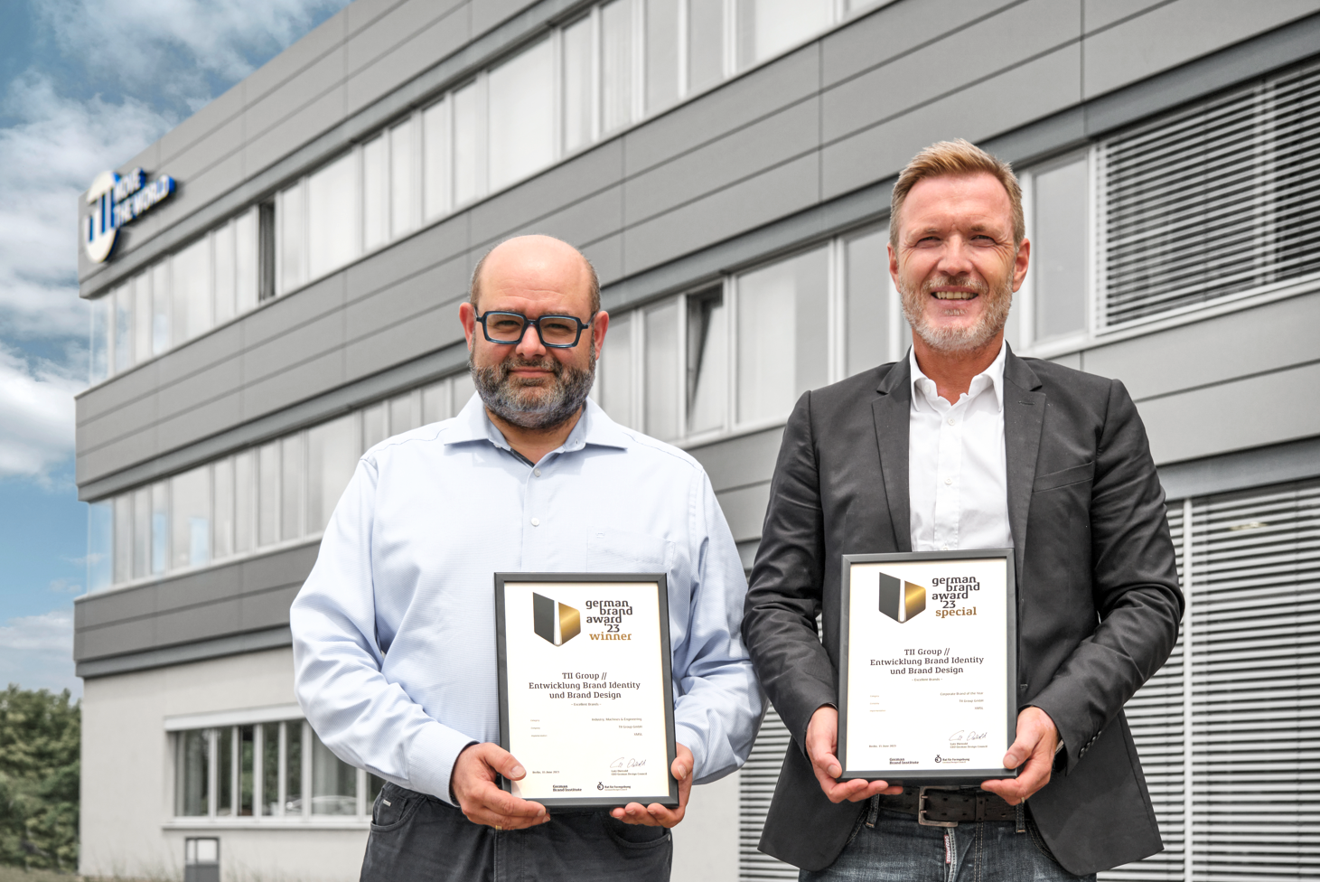
Patrick Gevelmann & Filippo Baldassari

Company profile
The TII Group, an Otto Rettenmaier family company from Heilbronn, is a manufacturer of heavy haulage and special transport vehicles with approximately 900 employees active worldwide. The Group includes the industry specialists TII SCHEUERLE and TII KAMAG with manufacturing plants in Germany and India and a worldwide organisation of sales and service partners. Included in the index of global leaders, the Group supports its customers in the transport and logistics, construction, plant engineering, aerospace, marine, power generation, steel and mining, as well as yard logistics, industries with their complex transport needs with its innovative vehicles for maneuvering and transportation. With a payload of over 20,000 tonnes, TII Group vehicles hold the current world record for transporting particularly heavy goods with a vehicle. TII stands for innovation from tradition, customer service and partnership as well as excellent quality products and sustainability in heavy haulage.

www.tii-group.com

Press contact
Irene Kromm
Marketing Manager & PR
irene.kromm@tii-sales.com

