Press Release | 11/08/2021
 | Pfedelbach

TII Group with three exhibits at Transport 2021 in Herning/Denmark

The TII GROUP will be presenting a range of innovations and solutions for the heavy haulage sector at Transport 2021 in Herning, Denmark, from 16th to 19th September 2021.
In Hall M/Stand 9430, visitors to the exhibition centre can admire the three exhibits at first hand: the completely redeveloped KAMAG PT terminal tractor, a particularly low, modular platform trailer from SCHEUERLE designed for loads with a high centre of gravity, the K25 L, along with the EuroCompact FL03, a manoeuvrable low-bed semi-trailer with a high payload capability.
Transport 2021 has been attracting thousands of visitors since 1988 and is Scandinavia's largest trade fair for the transport and logistics industry. With 375 exhibitors and more than 30,000 visitors, the biennial fair in Herning is one of the most important exhibitions in the transport and logistics sector.
KAMAG PT terminal tractor
With the KAMAG PT (PrecisionTractor), KAMAG is showing a completely redeveloped terminal tractor for yard logistics. With this special vehicle, even the heaviest of semi-trailers and container chassis can be moved efficiently and precisely. The hydrostatic drive ensures precise and continuous forward driving and reversing whereby the small turning circle guarantees easy manoeuvring also at depots with limited space. In addition, the driver´s cab has been completely redesigned: apart from an ergonomically optimised workplace, it offers a particularly good all-round view in order to prevent any collision damage. Furthermore, the direct access to the work platform makes it much easier to connect and disconnect the supply lines.
The new KAMAG PT has been specially designed for accommodating all handling tasks at haulage companies and logistics providers and CEP service providers as well as in the retail, wholesale and mail order sectors. With the fifth wheel load having been increased to 28 tonnes, the tractor is ideally suitable for terminal logistic operations at seaports, airports or rail companies as well as for yard logistics in industrial companies in the paper, steel and aluminium sectors.
SCHEUERLE K25 L platform vehicle
Modern wind turbines are becoming more and more powerful and larger which means the stability of the transport platform is an increasingly more significant factor when transporting individual components. SCHEUERLE has also developed the K25 L modular platform vehicle for the transport of plant and machinery with a high centre of gravity. The L in the type designation stands for low and is an indication of the particularly low platform height: In spite of the larger tyres (285/70 R 19.5), the lowered platform height is only 875 millimetres when loaded and 910 millimetres when unladen - this makes it easier to drive under the load. The K25 L is not only particularly low but also wide. Due to its track width of 2,100 millimetres, the risk of accidents because of overturning has been reduced many times over. Depending on customer requirements, the K25 L is available with two, four or six axles whereby the technically possible axle load can reach 23 tonnes or up to 13.9 tonnes when travelling at 80 km/h. The platform vehicle can be combined with a gooseneck, drawbar, swivel bolster, deck and tower adapter.

Scheuerle EuroCompact FL03 low-bed semi-trailer
The new FL03 three-axle low-bed semi-trailer of the EuroCompact series is likewise on display in Herning. With a payload of 48 tonnes, the model has set a new record in this vehicle segment. Despite the high payload, the FL03 is extremely compact: The basic length of the low bed measures 7,610 millimetres; thanks to the easily extendable telescopic slab deck, the trailer provides a loading length of 12,610 millimetres. As a result, this makes it suitable for haulage companies as well as transport assignments in the construction, agriculture and forestry sectors. The compact dimensions facilitate approval procedures and accelerate work processes during transport operations; in combination with a large steering angle, the tractor-trailer combination can also pass through narrow spaces without any problems. And thanks to the Clever Coupling System, the gooseneck can be easily disconnected and connected even on uneven terrain.

Photo:
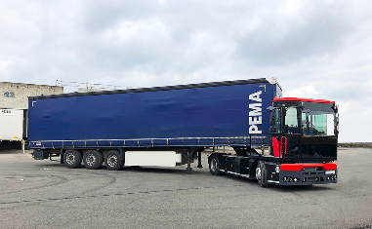
The new terminal tractor KAMAG PT.

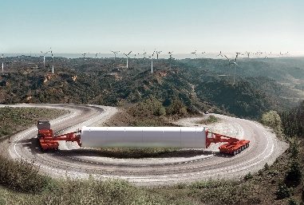
Optimized for the requirements of the wind power industry: the newly developed K25 L from SCHEUERLE.
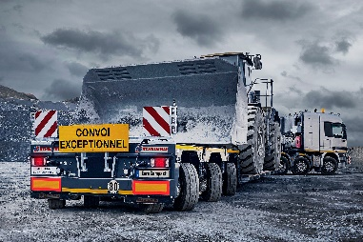
The SCHEUERLE EuroCompact FL03 in use at a stone pit.

Company profile
The Transporter Industry International Group (TII Group) is owned the Rettenmaier entrepreneurial family and is a globally active manufacturer of heavy-duty and special vehicles. It is comprised of the Scheuerle, Nicolas, Kamag and TIIGER brands, and has a workforce of around 900 employees. With innovative vehicles for logistics yards, public roads and industrial areas, the world market leader for heavy-duty vehicles with hydraulic pendulum axles supports its customers – from transport and logistics, building industry, plant engineering, air and space travel, shipbuilding through to energy, steel and mining – for realising a wide range of complex transport tasks. Transport assignments include construction machinery, wind turbine facilities, ships, antennas as well as entire factory plant. The TII Group holds the current world record of over 17,000 tonnes for transporting extremely heavy loads on vehicles. The TII Group focuses on product quality and innovations for the future of heavy-duty transportation mobility. In addition to locations in Germany, France and India, the group has a global sales and service organisation.
www.tii-group.com

Press contact
Carsten.Karkowski@tii-group.com

